7.54: To be at equilibrium at the bottom, with the spring compressed a distance 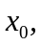 the spring force must balance the component of the weight down the ramp plus the largest value of the static friction, or 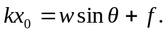 The work-energy theorem requires that the energy stored in the spring is equal to the sum of the work done by friction, the work done by gravity and the initial kinetic energy, or
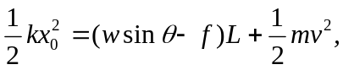
where L is the total length traveled down the ramp and v is the speed at the top of the ramp. With the given parameters, 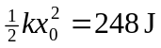 and 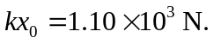 Solving for k gives 